Shan Group Hospital – A Commitment to Accessible, Quality Healthcare

SHAN Multi Speciality Hospital & Research Centre

Location: Amroha, Uttar Pradesh

About Us

Driven by an unwavering commitment to extend quality healthcare to underserved and remote regions of India, Shan Group proudly presents its state-of-the-art 100-bed multi-specialty hospital in District Amroha, Uttar Pradesh.

Shan Multi Speciality Hospital is a newly established, modern healthcare facility, dedicated to delivering compassionate, high-quality medical care with advanced infrastructure and a collaborative environment.

Hospital is equipped with facilities like X Ray, pathlab, dialysis, CT scan, MRI, Physiotherapy, OT, ICU, Ultrasound, dental and ophthalmology etc.
This advanced healthcare facility is designed to deliver world-class medical care through a blend of modern infrastructure, cutting-edge technology, and compassionate service. The hospital features advanced diagnostic laboratories, modern operation theatres, 24x7 emergency and OPD services, ensuring accessible, affordable, and reliable healthcare for individuals and families across the region.
With a vision to make quality healthcare available to every corner of the country, this hospital marks the first milestone in Shan Group’s larger healthcare mission — to establish a chain of modern, multi-specialty hospitals across India, particularly focusing on rural and remote communities.
Aligned with the vision of Dr. Shan Chaudhary, this initiative reflects the Group’s enduring dedication to social welfare, compassion, and excellence in patient-centered care. The hospital is committed to serving the poor and needy, addressing critical health challenges, and improving the overall quality of life through ethical, affordable, and innovative healthcare solutions.
Beyond expanding its hospital network, Shan Group is actively exploring ways to extend its healthcare initiatives to improve medical services in remote and underserved regions of India. The Group aims to collaborate with healthcare professionals, NGOs, and government bodies to strengthen medical outreach, telemedicine support, and community wellness programs.

Facilities and Services
- 24-hour patient admission and OPD services
- 24-hour normal and caesarean delivery facilities
- Comprehensive operation theatre for all types of surgeries
- Specialized treatment for gynecological and obstetric conditions
- Orthopedic and joint care specialists available
- Dedicated cardiology consultation and treatment
- Daily consultation by skilled and experienced doctors
- Minimally invasive (laparoscopic/telescopic) and open surgical procedures
- 24-hour ambulance and emergency response service
- Fully equipped diagnostic departments with:
  - X-ray, MRI, CT Scan, and Ultrasound
  - Advanced Pathology and Laboratory Testing Facilities

🏥 1️⃣ Core Clinical Care Services

R – Role

Provide continuous and comprehensive primary and specialty medical care.

O – Objective

Ensure patients receive timely diagnosis, treatment, and follow-up under expert supervision.

C – Context or Details

• 24-Hour Patient Admission and OPD Services
Round-the-clock admission and outpatient services ensure uninterrupted access to medical care. Patients can seek consultation, follow-up treatment, and emergency attention at any hour. A structured triage system prioritizes urgent cases while maintaining efficient patient flow and documentation accuracy.

• Daily Consultation by Skilled and Experienced Doctors
Experienced physicians conduct daily consultations across multiple specialties. Each consultation focuses on accurate diagnosis, personalized treatment planning, preventive guidance, and patient education. Coordinated case discussions ensure continuity of care and multidisciplinary support when required.

• Dedicated Cardiology Consultation and Treatment
The cardiology department provides evaluation and management of heart-related conditions, including hypertension, coronary artery disease, arrhythmias, and heart failure. Preventive cardiac screenings, ECG monitoring, and treatment planning are performed under specialist supervision for optimal patient outcomes.

• Orthopedic and Joint Care Specialists Available
Orthopedic specialists diagnose and treat fractures, arthritis, sports injuries, spinal disorders, and joint problems. Treatment includes medication, physiotherapy guidance, and surgical intervention when required. Rehabilitation plans are tailored to restore mobility and improve long-term musculoskeletal health.

• Specialized Treatment for Gynecological and Obstetric Conditions
Comprehensive women’s healthcare services include prenatal care, fertility evaluation, menstrual disorder management, menopause care, and high-risk pregnancy monitoring. Patient-centered counseling and evidence-based treatment ensure safety and comfort at every stage of reproductive health.

🏥 2️⃣ Surgical & Procedural Infrastructure

R – Role

Deliver safe, modern, and advanced surgical care.

O – Objective

Provide precise surgical intervention with minimal complications and faster recovery.

C – Context or Details

• Comprehensive Operation Theatre for All Types of Surgeries
Fully equipped operation theatres support general, orthopedic, gynecological, and specialty surgeries. Sterile environments, advanced anesthesia systems, and modern surgical instruments ensure patient safety. Strict infection control protocols and monitoring systems maintain high clinical standards.

• Minimally Invasive (Laparoscopic/Telescopic) and Open Surgical Procedures
Advanced laparoscopic procedures allow smaller incisions, reduced pain, and quicker recovery. When necessary, open surgeries are performed with precision and safety. Surgeons evaluate each case carefully to choose the most effective and least invasive approach possible.

• 24-Hour Normal and Caesarean Delivery Facilities
Maternity services operate continuously with experienced obstetricians and trained nursing staff. Facilities support both normal deliveries and caesarean sections, including high-risk cases. Continuous fetal monitoring and neonatal care ensure safe childbirth experiences for mother and baby.

🚑 3️⃣ Emergency & Transport Services

R – Role

Provide immediate response and life-saving intervention.

O – Objective

Ensure rapid stabilization and safe transport of patients during emergencies.

C – Context or Details

• 24-Hour Ambulance and Emergency Response Service
Emergency teams respond promptly to trauma, cardiac events, and urgent medical conditions. Ambulances are equipped with life-support systems and trained paramedics. Quick coordination between ambulance services and hospital emergency units minimizes critical response time.

🔬 4️⃣ Diagnostic & Laboratory Services

R – Role

Deliver accurate and timely diagnostic evaluation.

O – Objective

Support precise clinical decisions through advanced imaging and laboratory analysis.

C – Context or Details

• X-ray Imaging Services

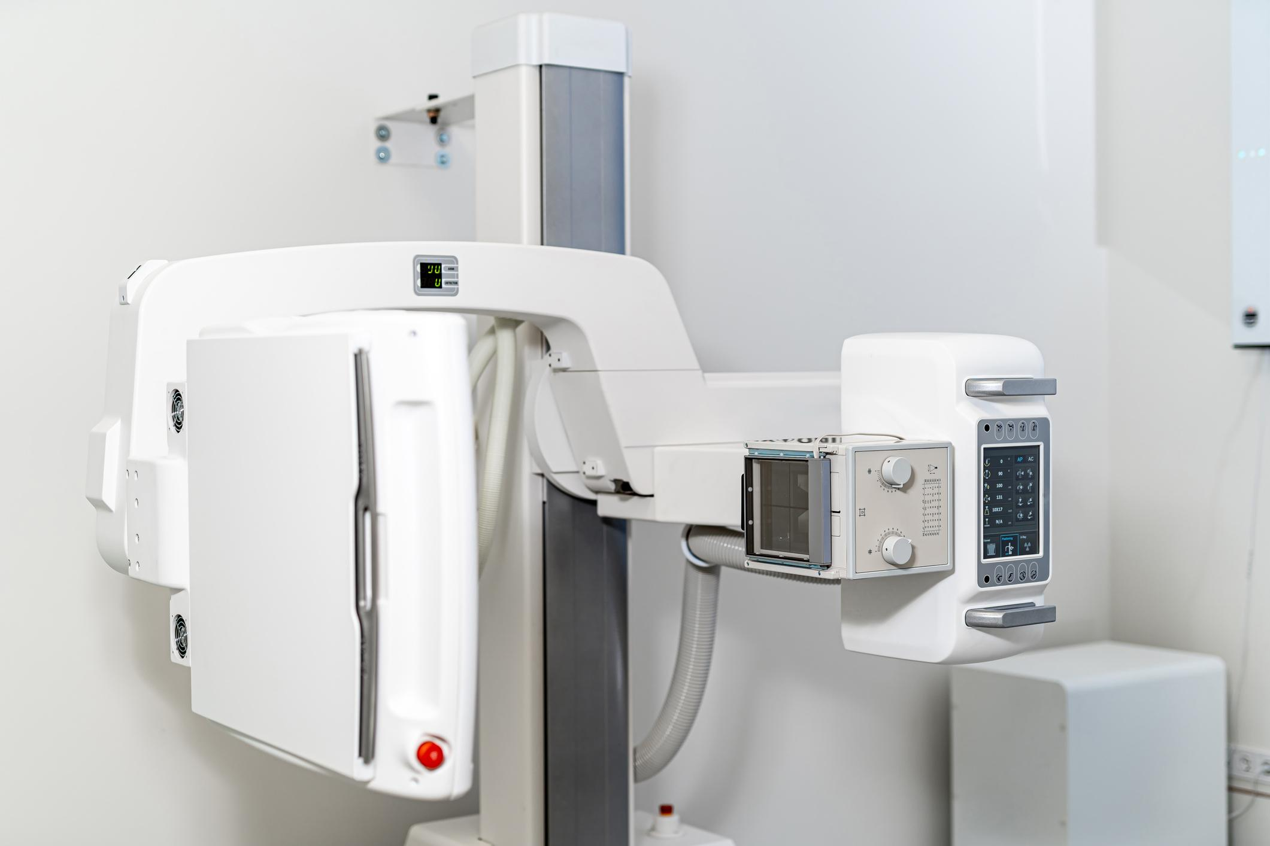

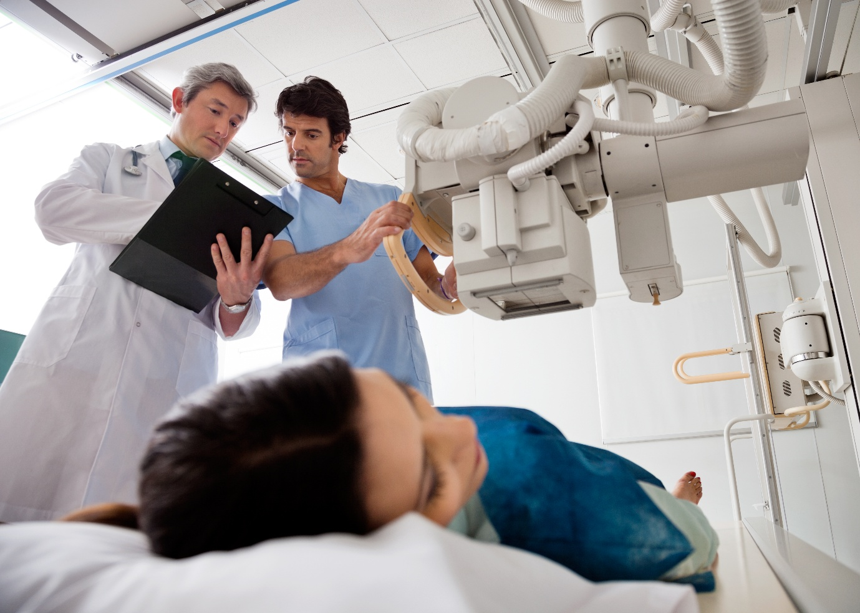

4

Digital radiography systems provide fast and accurate imaging for fractures, chest conditions, and internal abnormalities. Radiologists analyze images promptly to assist physicians in diagnosis and treatment planning while maintaining strict radiation safety standards.

• MRI and CT Scan Facilities

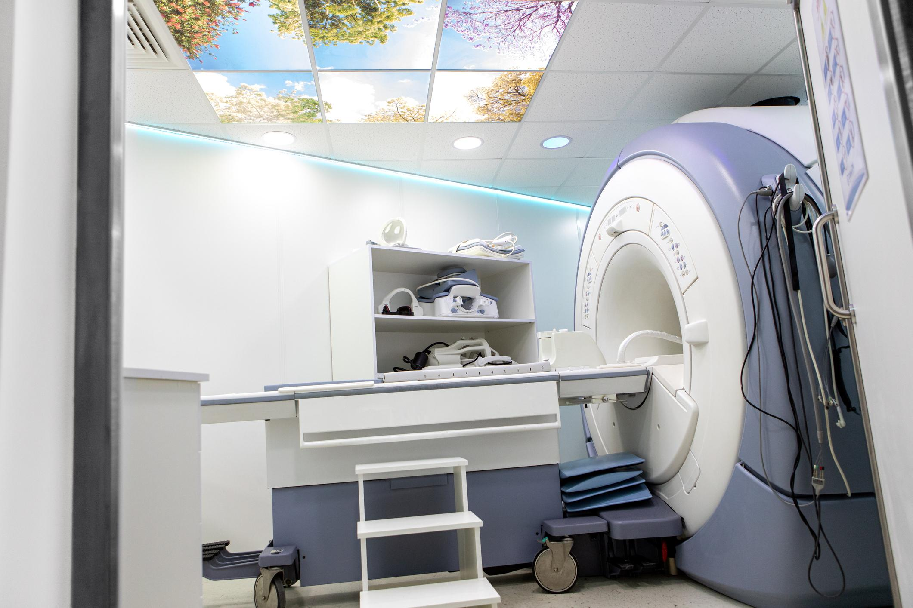

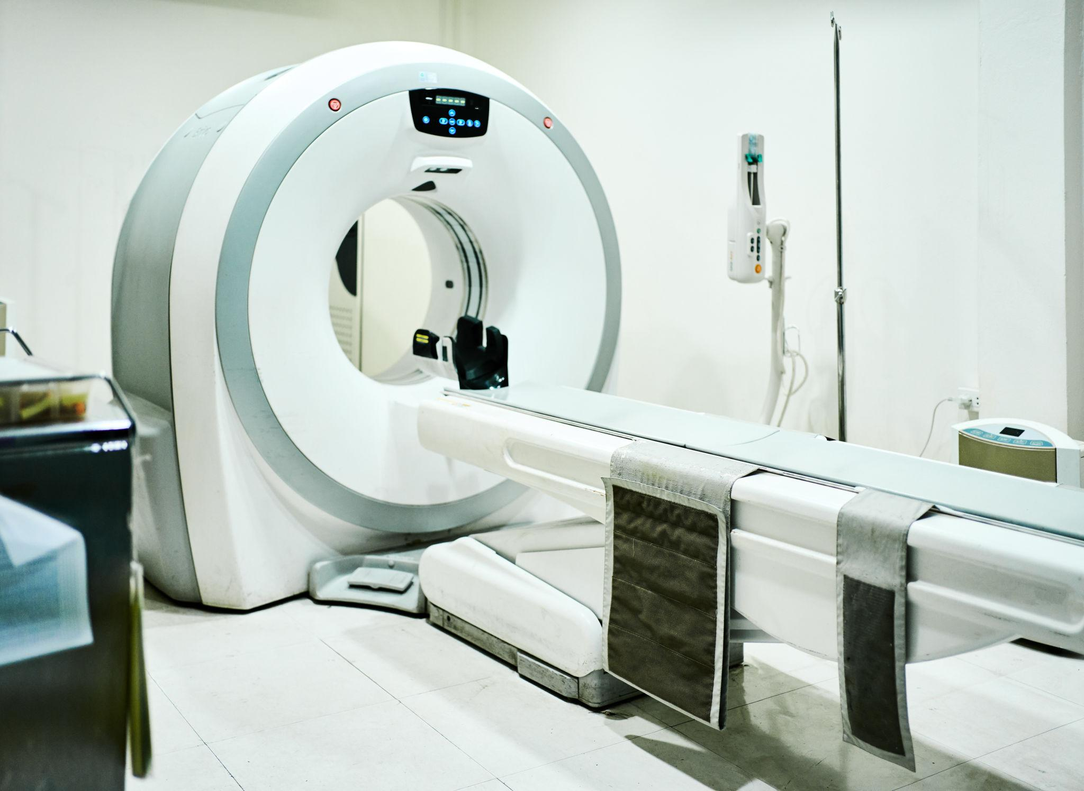

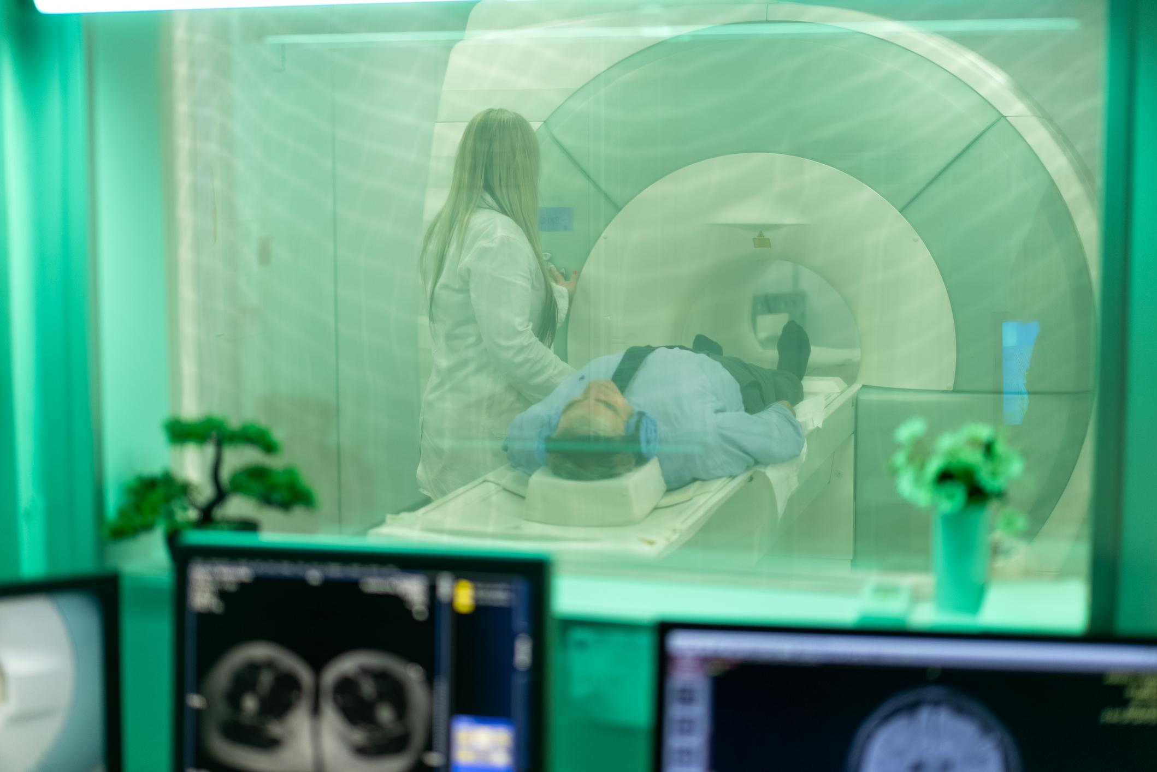

4

Advanced MRI and CT scan systems offer detailed cross-sectional imaging for neurological, cardiac, abdominal, and musculoskeletal conditions. High-resolution imaging improves diagnostic precision, aiding early detection and effective treatment strategies.

• Ultrasound Services

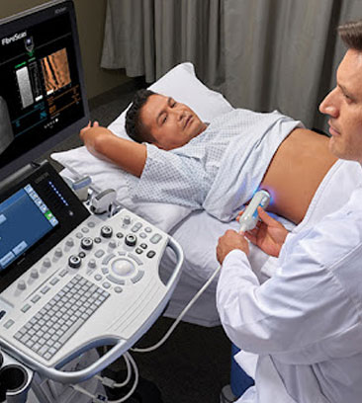

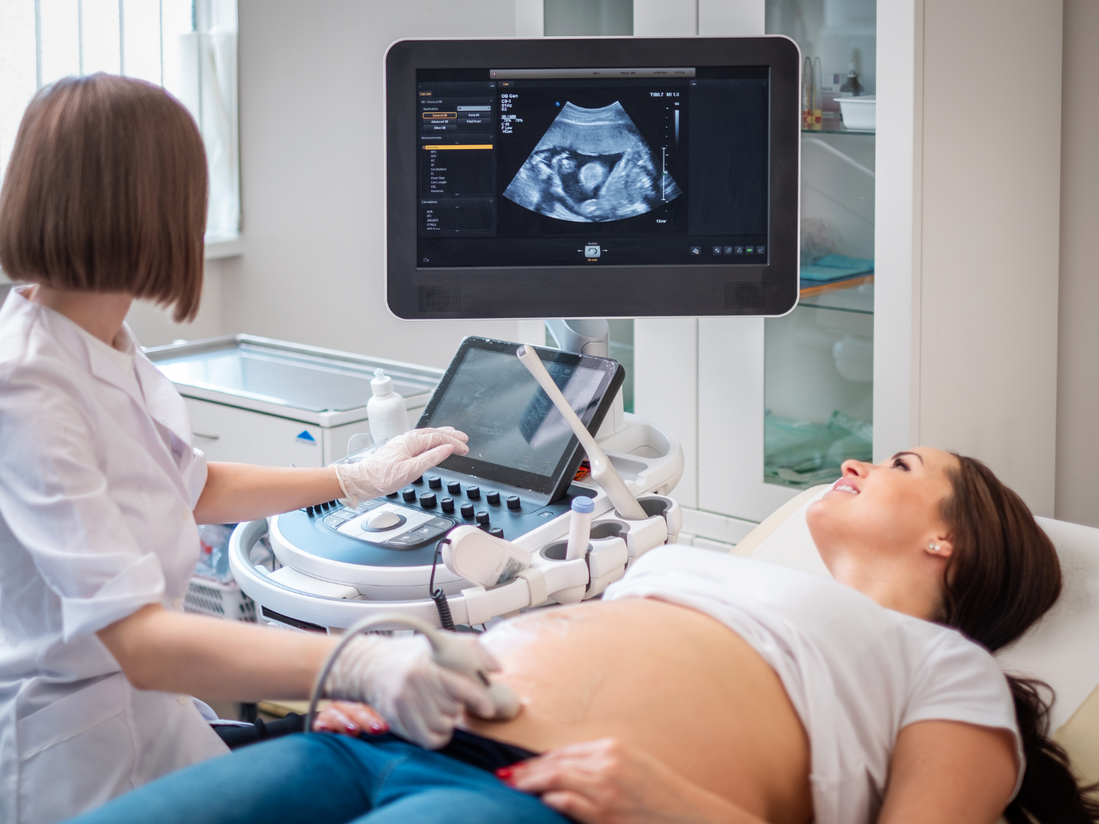



4

Ultrasound imaging supports pregnancy monitoring, abdominal assessment, and soft tissue evaluation. Non-invasive and safe, this technology enables real-time visualization, assisting physicians in making informed clinical decisions.

• Advanced Pathology and Laboratory Testing Facilities

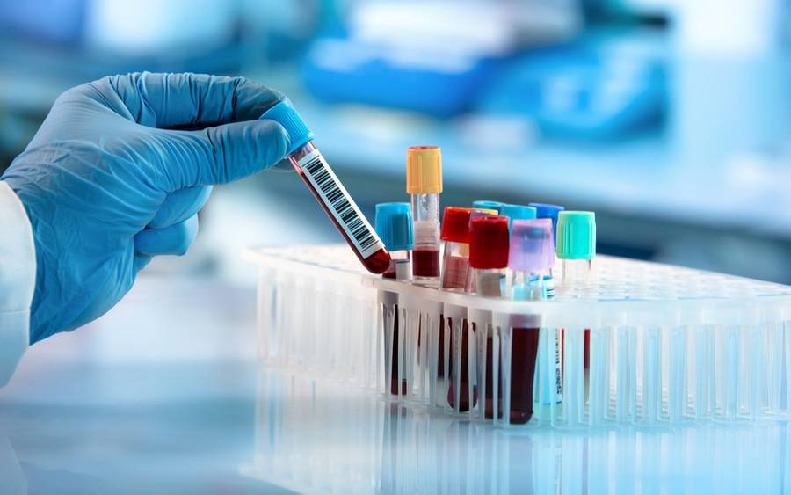

4

The pathology laboratory conducts blood tests, biochemical analysis, microbiology screening, and specialized diagnostics. Automated analyzers ensure accuracy and quick turnaround times, enabling physicians to make prompt and reliable treatment decisions.

A Vision for a Healthier Future
The Shan Group Hospital stands as a symbol of hope, innovation, and social responsibility — where medical excellence meets compassionate service. As Shan Group continues to expand its healthcare footprint, it remains steadfast in its mission to build healthier communities and a stronger, more equitable India.

Contact Us: Form fill
Email: info@shangroup.co.in

